**The Calculator Application**

The Calculator application(app) performs simple to advanced mathematical calculations. You can perform mathematical calculations at high-speed, saving time and effort. The calculator app displays commonly used, basic operators in the main display and more advanced features inside the menu. Most devices like computers, and mobile phones will have the calculator app pre-loaded. You can also download the calculator app from the App store or download it online.

On launching, the Calculator app opens in the Standard mode, with the commonly used operators. You can navigate to the Advance features by clicking the open navigation in the top left corner of the app.

Image below shows the calculator in Standard mode

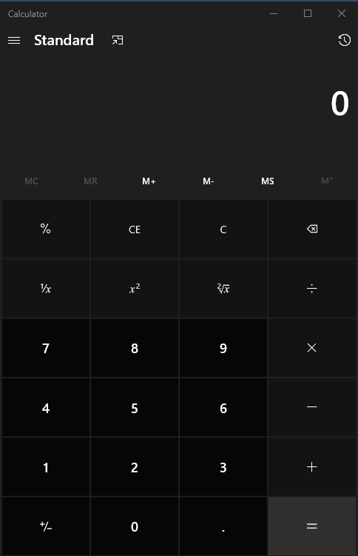

Image Below shows the Navigation menu in the calculator, you can select advanced features from this list.

